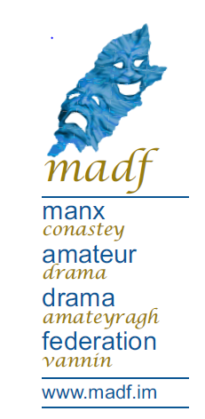

Participant Safeguarding & Consent Form
  - To be completed by individual participants or team leads

Team or Individual Information
Team Name | Main Contact Name | Email or Phone

Participant Details
List participants who are children (under 18), as well as adults who have learning disabilities, complex medical needs (ie epilepsy, epi- pen use, chronic asthma), neurodiverse, or any circumstances that may require reasonable adjustments.
Participant Name | Requirements or < 18 | Is Reasonable Adjustment Needed?
 |  | [ ] Yes [ ] No
 |  | [ ] Yes [ ] No
 |  | [ ] Yes [ ] No

Children & Licensing
Definition: A child is under 16, or 16 but still of compulsory school age (not yet reached the last Friday in June of the school year in which they turn 16).
Child’s Name | Date of Birth | School | Chaperone

- There must be at least 1 licensed chaperone for every 11 children (1:11 ratio).
- Chaperones must be present with children throughout all rehearsals and performances.
- The named chaperone is responsible for the child's welfare and must be reachable during MADF events.
- Chaperones must not be part of the production company.

Photography Permission
Individual/Team Name | Permission for Photos/Video? [Yes/No]
Tick or mark ‘Yes’ to give permission for official MADF photography, which may be used for promotional purposes.

Responsibility & Code of Conduct
- Teams and individuals are responsible for ensuring all participants are respectful and considerate to others throughout MADF events.
- Please inform MADF organisers of any concerns regarding safeguarding, welfare, or adaptations.

Safeguarding Queries
If you have any concerns regarding safeguarding at any stage during a MADF event , please contact the named safeguarding lead: Leandra Lawler.
Email: chairman@madf.im

Declaration (Individuals 18+, Parents/Guardians of Minors – Teams & Teams with Licensed Children)
The team representative /Individual below confirms that all details provided above are accurate, all child protection/welfare responsibilities will be observed. By signing, you accept responsibility for ensuring you/your team follow codes of conduct and all supervision requirements are met in accordance with MADF policies.
Team representative, parent/guardian or individual | Signature | Date

All information will be treated confidentially and used solely for safeguarding purposes during the MADF events.

GDPR & Data Use Notice
In accordance with the General Data Protection Regulation (GDPR), your information will be securely stored and managed by MADF organisers. Data will only be accessed by relevant staff for safeguarding purposes and will not be shared with third parties unless required by law. All information will be retained for the duration of 1 year (unless requested to remove) and a limited period thereafter for legal and safeguarding reasons, after which it will be securely deleted or destroyed. If you have any questions about how your data is used, or wish to exercise your rights under GDPR, please contact MADF Safeguarding Officer.

